Name : عبدالرحمن محمد سالم حسن section : 1 BN : 38
LAB1
Student experiment 1:
a)
>> nx = [-3:7]
nx =
-3 -2 -1 0 1 2 3 4 5 6 7
>> x = zeros(1,length(nx));
>> x(1,find(nx==0)) = 2;
x(1,find(nx==2)) = 1;
x(1,find(nx==3)) = -1;
x(1,find(nx==4)) = 3;
>> x
x =
0 0 0 2 0 1 -1 3 0 0 0
>> stem(nx,x);
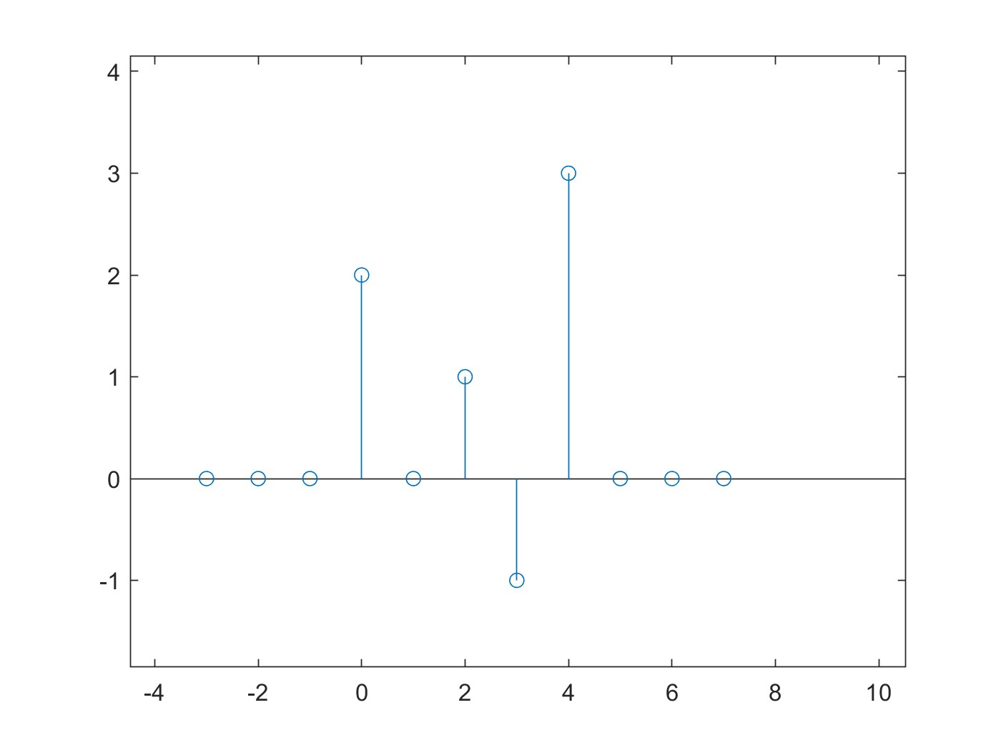

b) Graph
y1[n]=x[n-2];
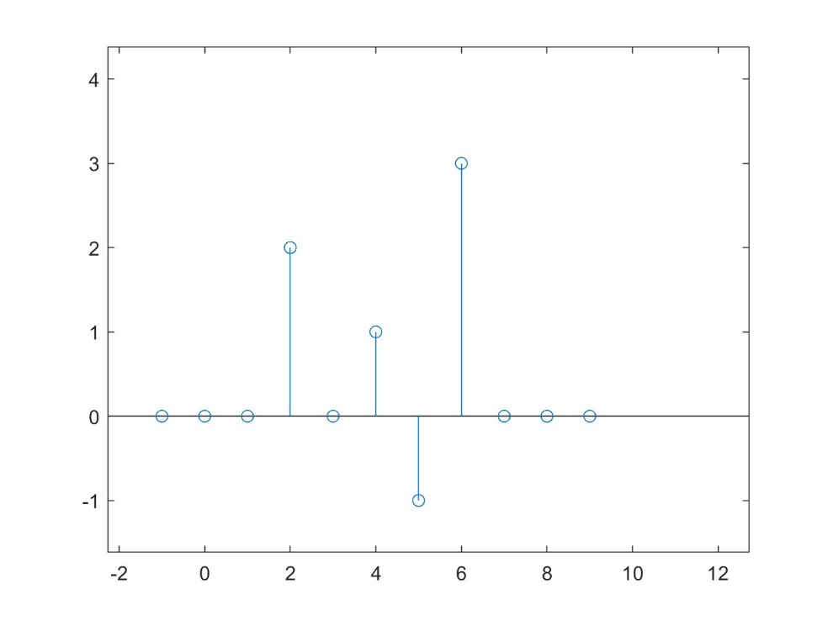
>> stem(nx+2,x);

y2[n]=x[n+1];
>> stem(nx-1,x);
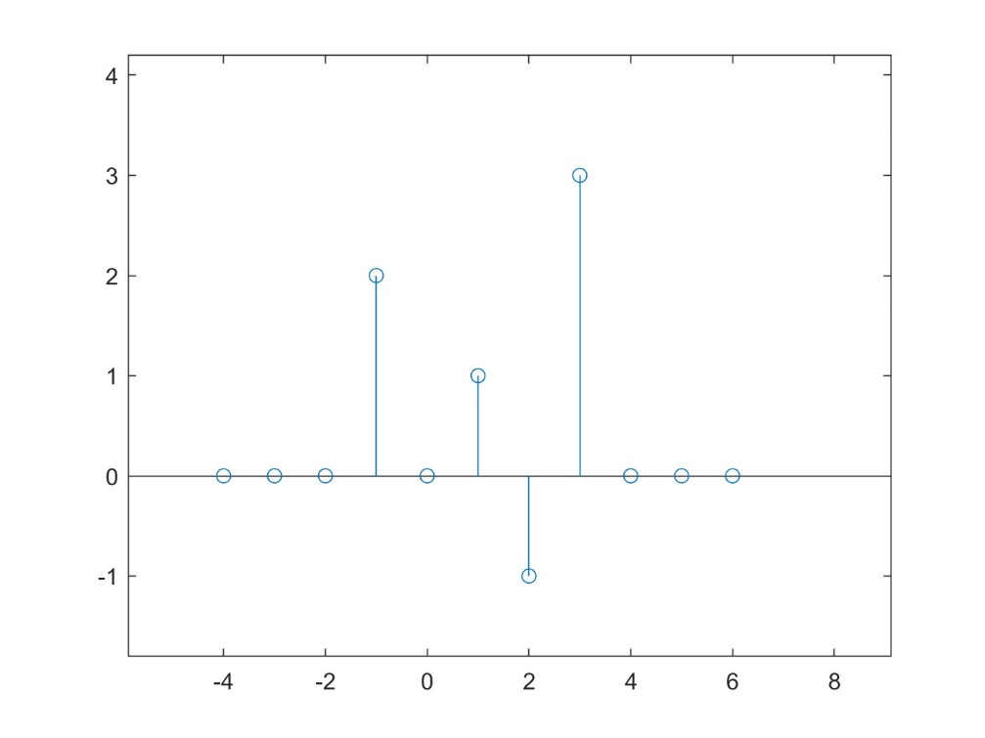

y3[n]=x[-n];
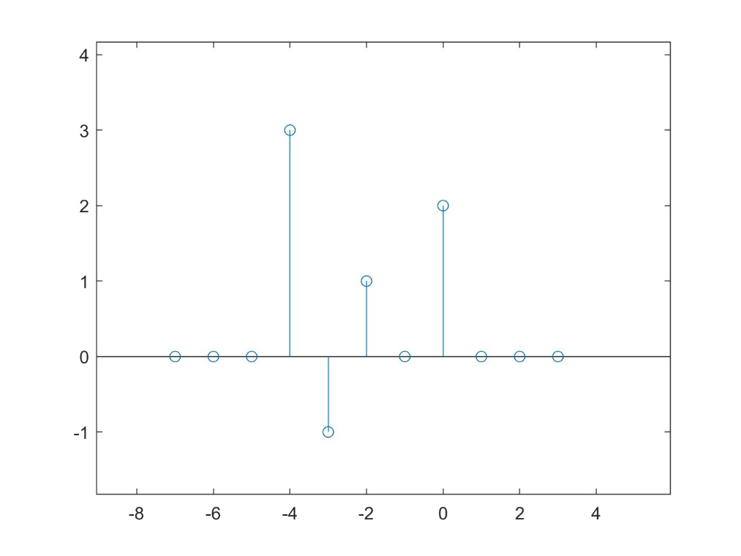
>> stem(-nx,x);

y4[n]=x[-n+1];
>> hold on
stem(-nx+1,x);
stem(nx,x);
hold off
legend('-nx+1','nx')
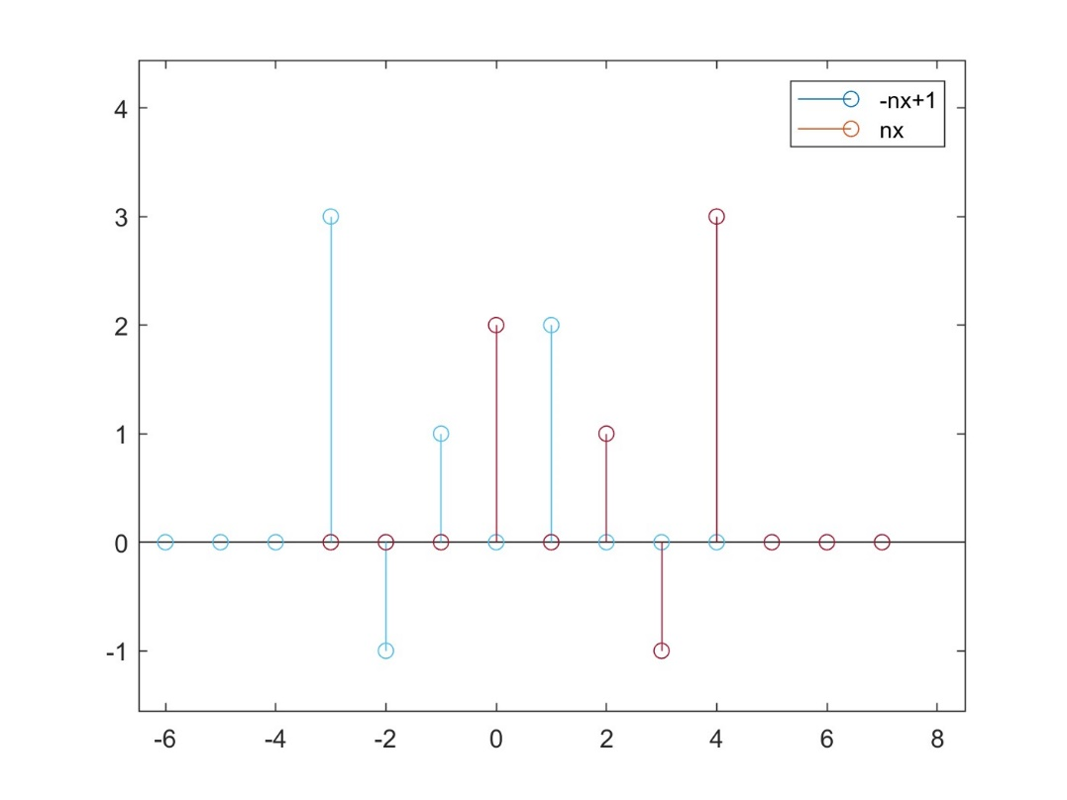

Student experiment 2:
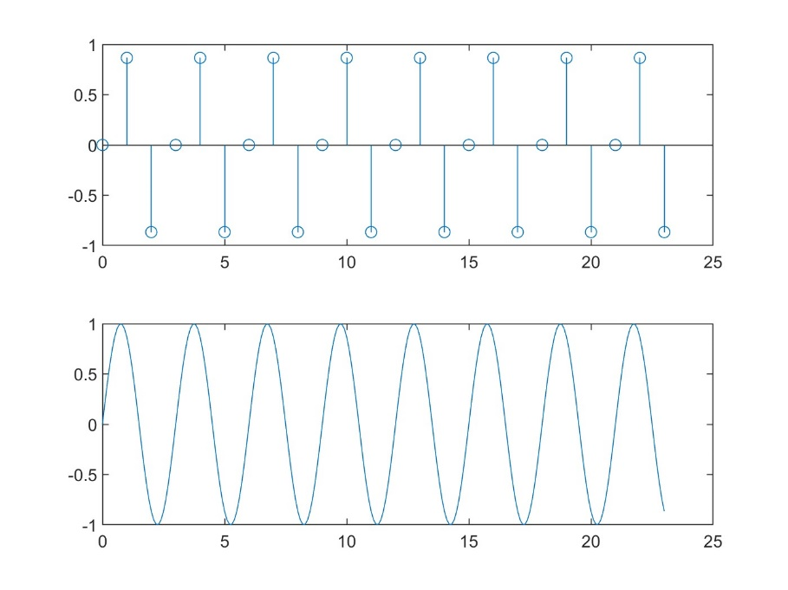

M = 4
>> n=[0:23];
>> x=sin(2*pi*4/12*n);
>> subplot(2,1,1);
>> stem(n,x);
>> t=[0:.1:23];
>> xt=sin(2*pi*4/12*t);
>> subplot(2,1,2);
>> plot(t,xt);
Fundamental period of discrete signal = 3

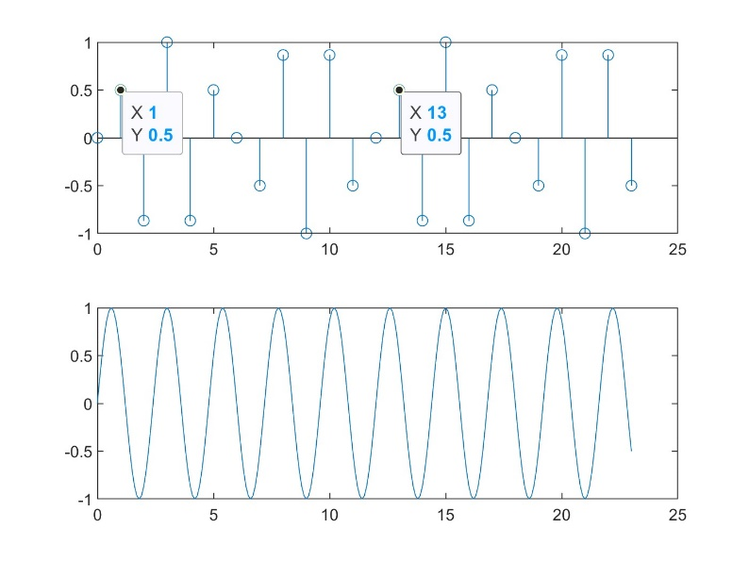
M = 5
>> n=[0:23];
>> x=sin(2*pi*5/12*n);
>> subplot(2,1,1);
>> stem(n,x);
>> t=[0:.1:23];
>> xt=sin(2*pi*5/12*t);
>> subplot(2,1,2);
>> plot(t,xt);
Fundamental period of discrete signal = 12

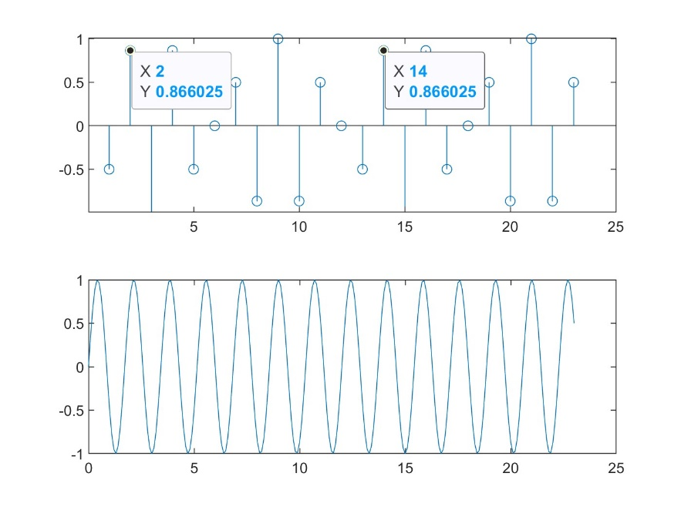
M = 7
>> n=[0:23];
>> x=sin(2*pi*7/12*n);
>> subplot(2,1,1);
>> stem(n,x);
>> t=[0:.1:23];
>> xt=sin(2*pi*7/12*t);
>> subplot(2,1,2);
>> plot(t,xt);
Fundamental period of discrete signal = 12

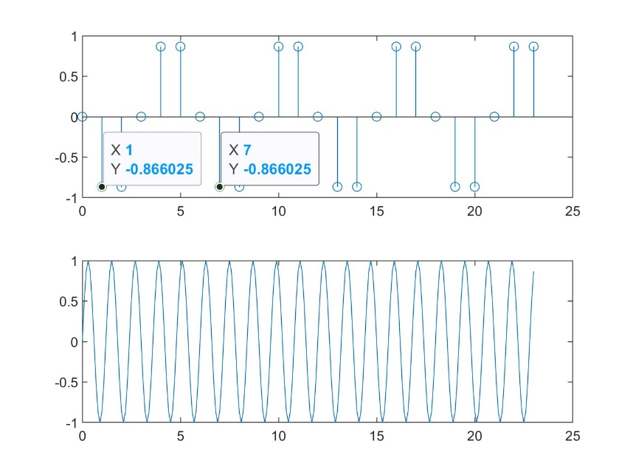
M = 10
>> n=[0:23];
>> x=sin(2*pi*10/12*n);
>> subplot(2,1,1);
>> stem(n,x);
>> t=[0:.1:23];
>> xt=sin(2*pi*10/12*t);
>> subplot(2,1,2);
>> plot(t,xt);
Fundamental period of discrete signal = 6

answer to how fundamental periods can be determined from N and M:
$$ω= \frac{2π M}{N}$$
So from above equation : N is the fundamental period of discrete signal
So :
$$N= \frac{2π}{ω} M$$
Since both M and N must be integers then choose the smallest value of M the makes $\frac{2π}{ω}$ integer value so that N becomes an integer and that you have N which is the smallest integer representing the fundamental period of the discrete wave.

- K = 1
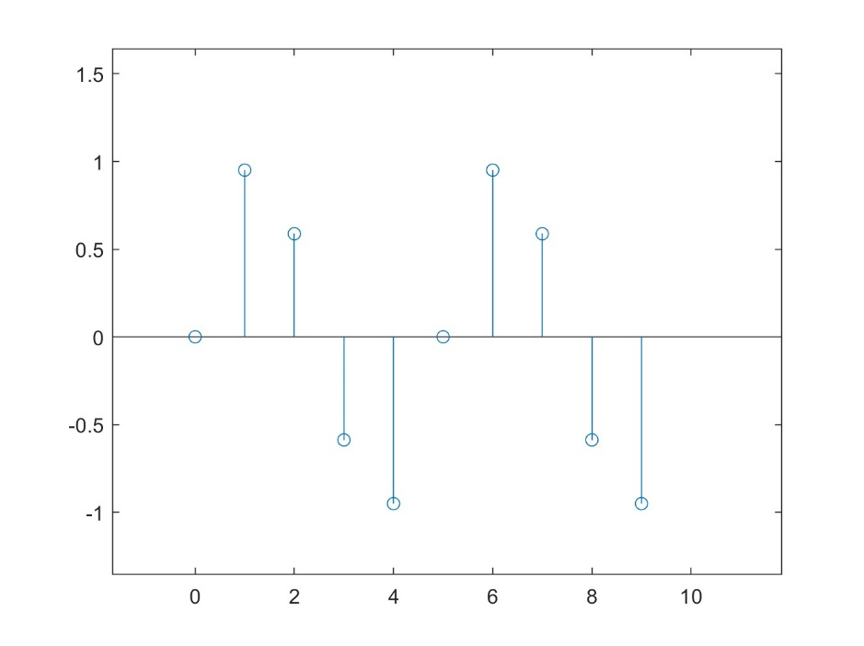

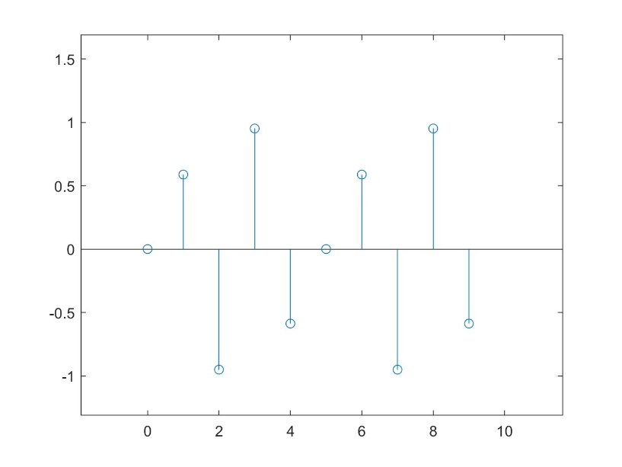
K = 2

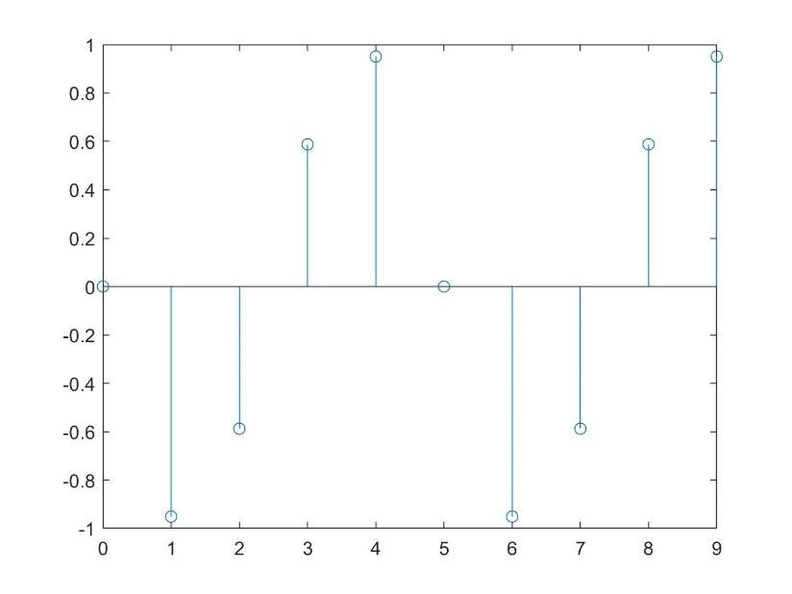
K = 4

K = 6
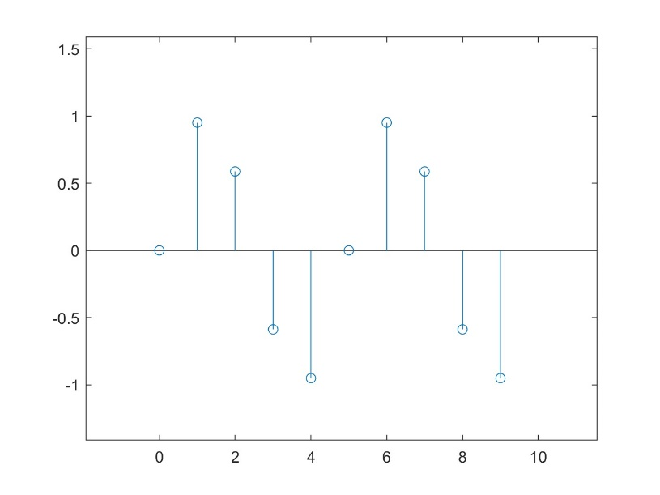

There is 3 unique graphs above : as when k = 6 or k = 1 , in both cases it gives the same graph. Because $ω= \frac{2π M}{N}$ so at k = 1 : $ω= \frac{2π*1}{5}$ and when k = 6 : $ω= \frac{2π*6}{5}$ , since sin wave is periodic with period $2π$ so :
$$\sin\left(\frac{2π*6}{5}\right)= \sin\left(\frac{2π*(1+5)}{5}\right)= \sin\left(\frac{2π*1+2π* 5}{5}\right)= \sin\left(\frac{2π*1}{5}+2π\right)= \sin\left(\frac{2π*1}{5}\right)$$
Student experiment 3:
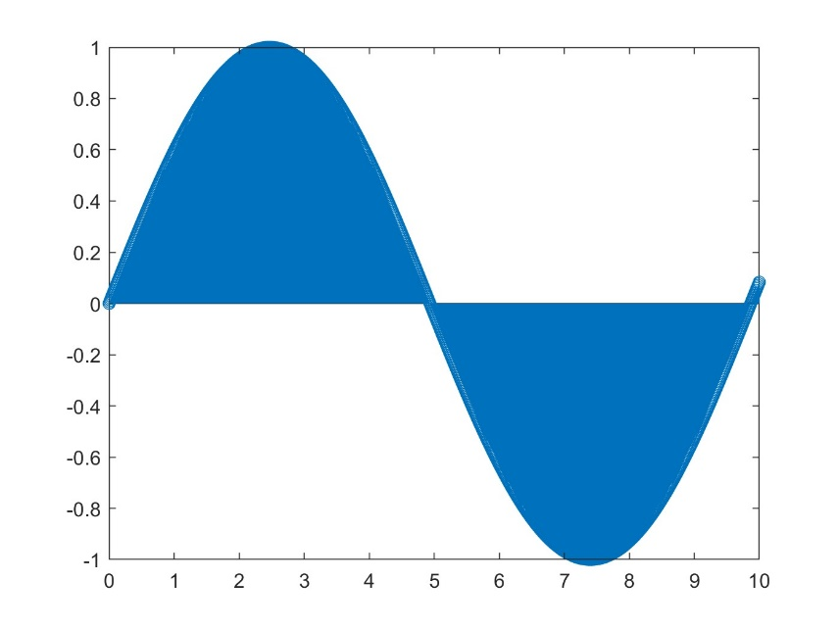
- Sinusoidal function: $sin⁡(\frac{4}{2π}*n)$
>> n=[0:0.01:10]
>> x=sin(4/(2*pi)*n);
>> stem(n,x);
%this is the first method to calculate the total power and energy
>> Etot=sum(x.^2);
>> Ptot=Etot/length(x);
- Total power = 0.4930
- Total energy for that interval = 493.5137
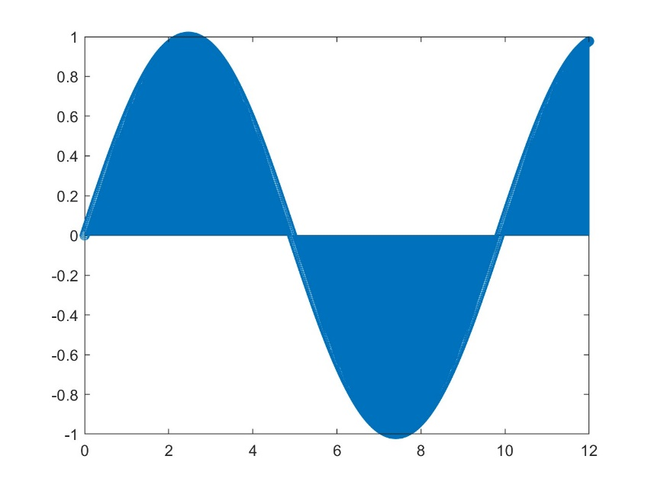
>> n=[0:0.01:12]
>> x=sin(4/(2*pi)*n);
>> stem(n,x);
%this is the first method to calculate the total power and energy
>> Etot=sum(x.^2);
>> Ptot=Etot/length(x);

- Total power = 0.4864 (nearly same as in (a))
- Total energy for that interval = 584.1396
(Greater than that in (a) as it’s greater in period)
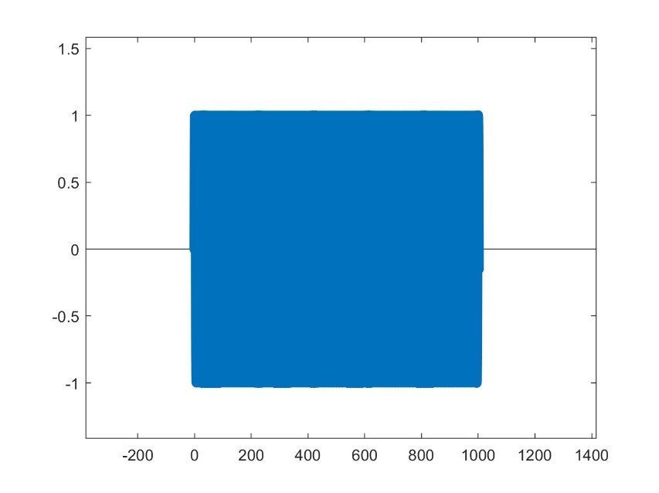
>> n=[0:0.01:1002]
>> x=sin(4/(2*pi)*n);
>> stem(n,x);
%this is the first method to calculate the total power and energy
>> Etot=sum(x.^2);
>> Ptot=Etot/length(x);

- Total power = 0.4999 (nearly same as in (a))
- Total energy for that interval = 5.0088e+04
(Greater than that in (a) as it’s greater in period)
Comments: b , c are both periodic as they are only part of an infinity domain from -infinity to +infinity , so I can consider them as periodic signals , for the power it nearly the same in the 3 cases whatever the domain is , the power stayed the same as sin wave is power signal not energy signal so the power is finite whatever the domain is while the energy is infinite and it’s increasing towards infinity as we widen the domain of the signal that’s why the energy of the signal increased every time we increase the domain while the power stayed nearly the same as it’s defined as the energy of one period over its time.

